SHIBORI
Lesson instructions and extra resources.
NOTE: All videos have been created in SafeShare. These videos are ad free and appropriate
for students.

With this exercise you need to:
1st: Watch this short video about Sir Isaac Newton and what he learned about color.
Sir Isaac Newton and Color
2nd: Watch this short video about color.
Evolution of Color
3rd: Watch this video about an art form called Shibori.
Fun with the SHIBORI technique!
4rd: TRY IT! Get creative!
-Create some tissue paper designs, using the shibori technique.
-Explore and try new ways to create shibori designs using materials around your home.
- Use what you know about colors and how they work in harmony together
EXAMPLE HAND DYING EXAMPLE
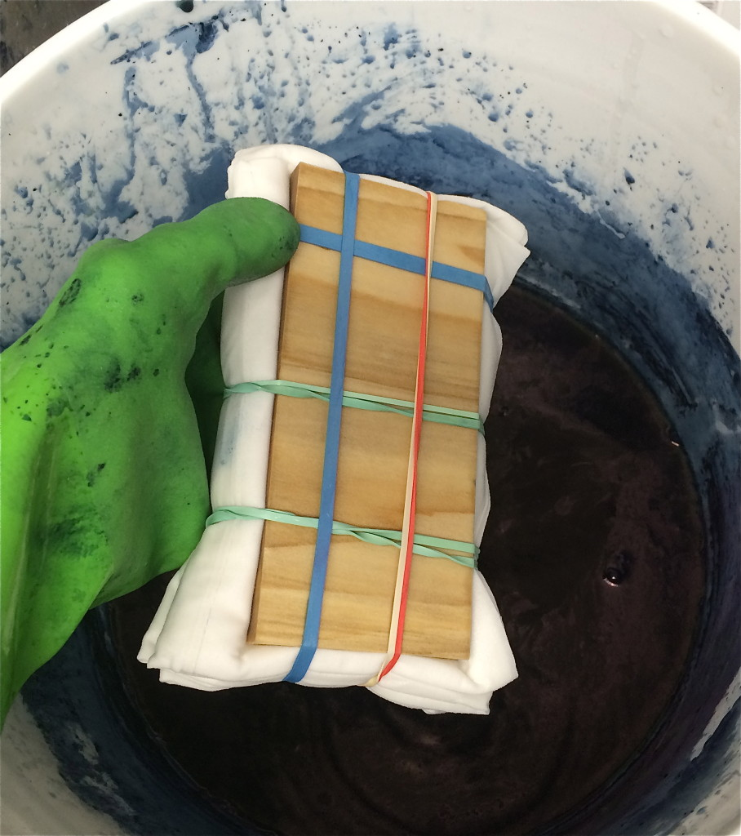
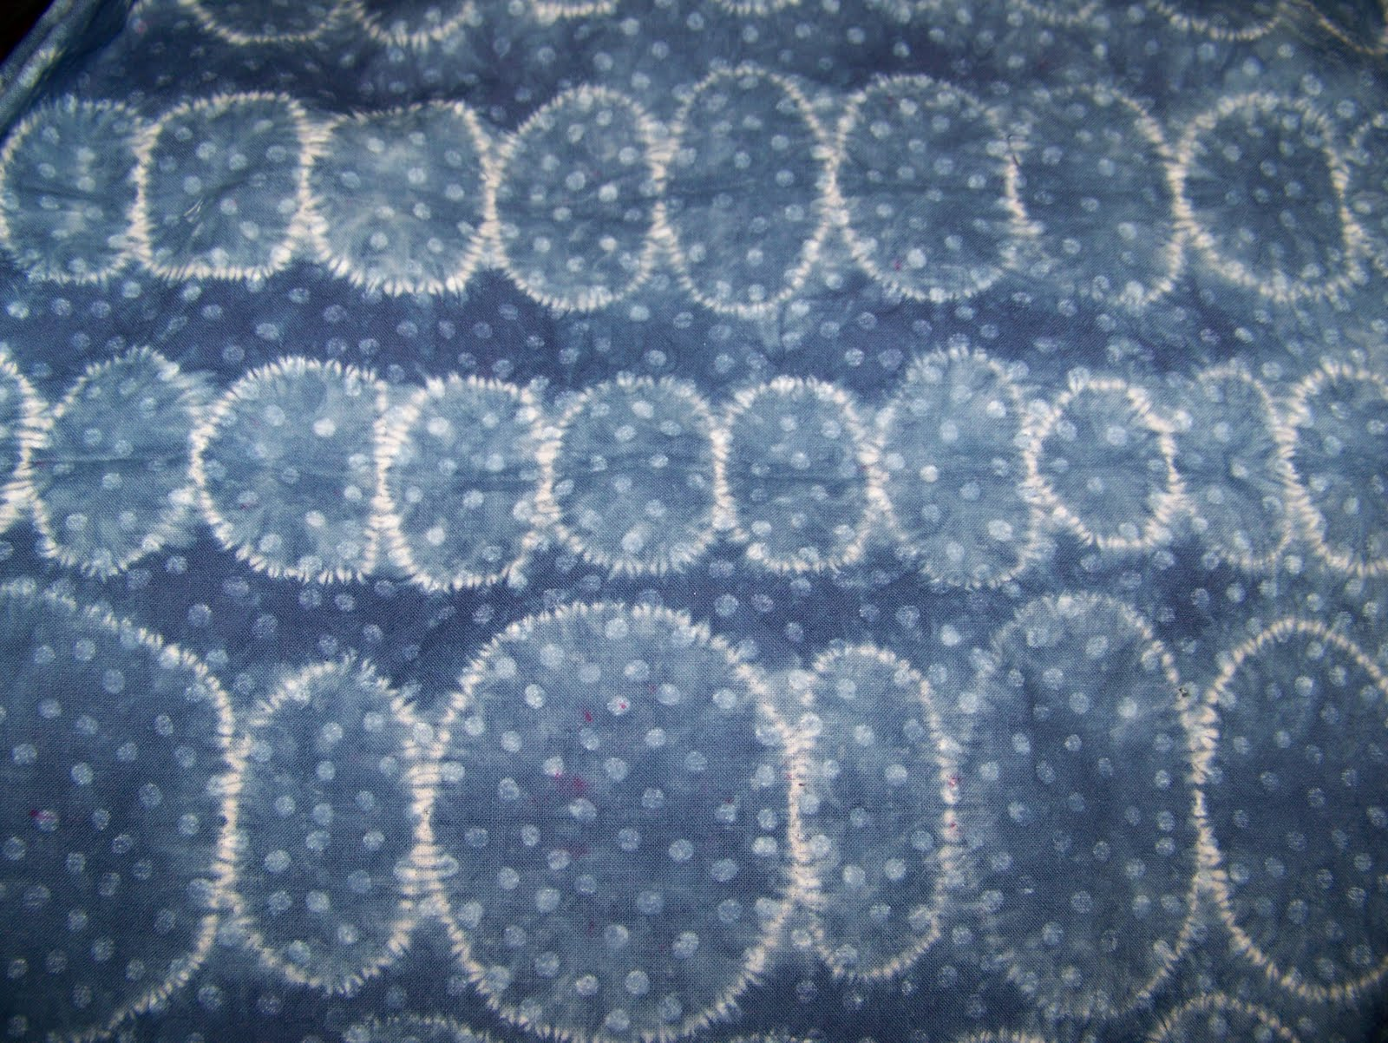
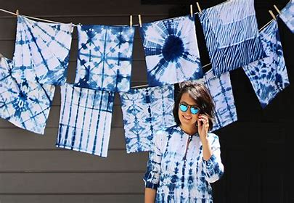

4th: Take a picture or video of your work. Make sure I know it is yours!
Upload it to the Art file for your grade – which you will find in CLEVER or email it to:
louise.culpepper@cobbk12.org

