Trouble Viewing a Video?
On some systems, the video links I have created in SafeShare don’t open correctly. Your screen may spool or look like what is displayed below. Here is what you do…. .
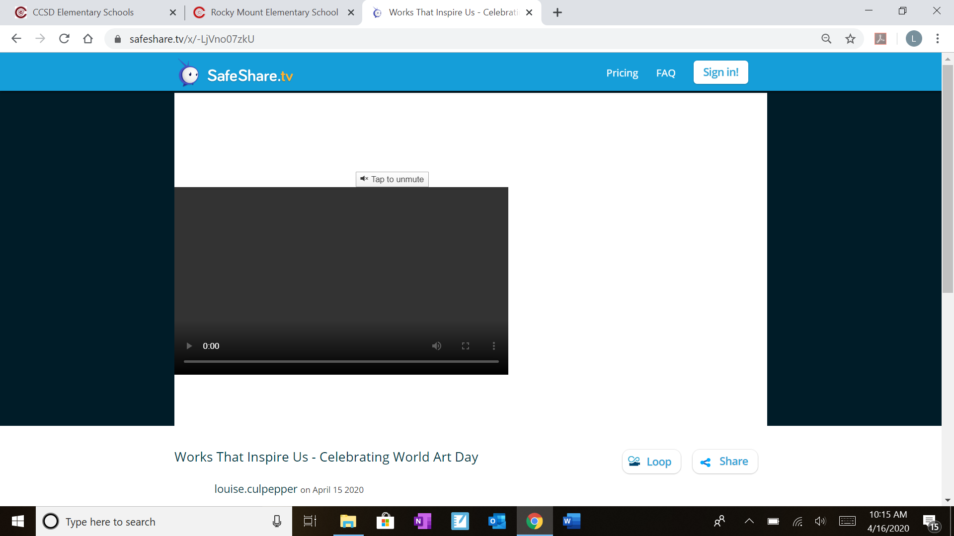
CLICK ON THE LOOP BUTTON

