LAND ART
Lesson instructions and extra resources.
NOTE: All videos have been created in SafeShare. These videos are ad free and appropriate
for students.

With this exercise you need to:
1st: Watch this Power Point/Video on Andy Goldsworthy.
CREATING OUTDOORS - Andy Goldsworthy

2nd: Watch this Land Art video.
LAND ART
3rd: TRY IT! Get creative!
-Investigate nature and create a design of your choice.
-Your design/composition can look like something or it can be something abstract.
-Use what you know about the Elements of Art:
Line Shape Form Color Value Texture Space

EXAMPLES
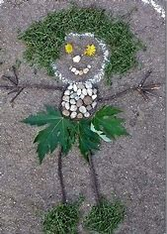
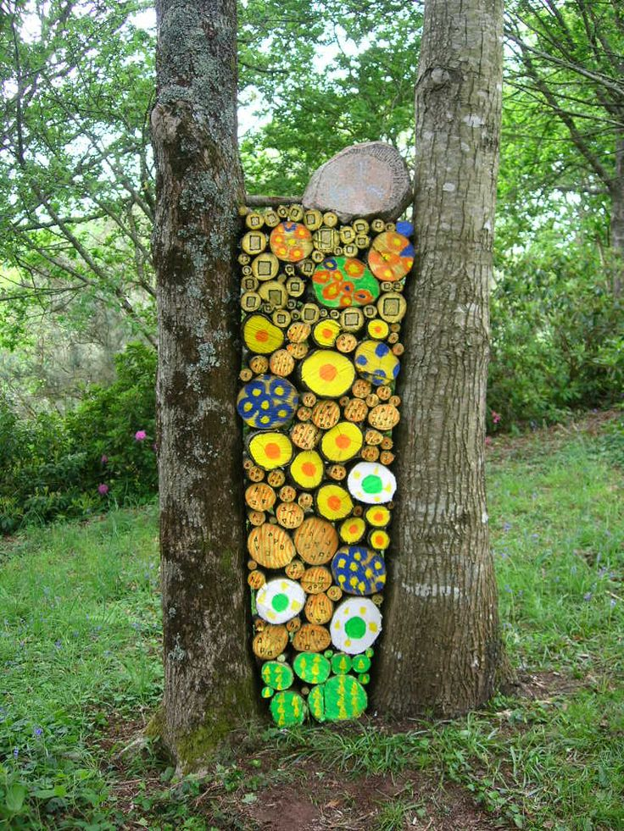
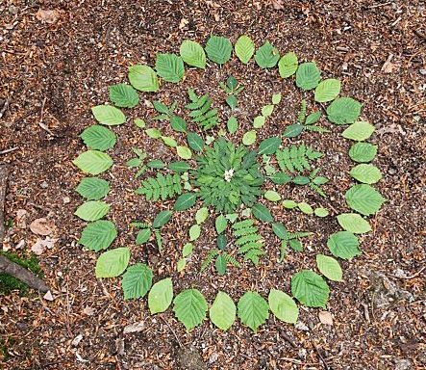

4th: Take a picture or video of your work.
PLEASE put your name on it…… make sure I know it is yours
Upload it to the Art file for your grade – which you will find in CLEVER or email it to:
louise.culpepper@cobbk12.org

Additional Learning
SPIRAL JETTY - Robert Smithson

Build Like Andy

Andy Goldsworthy_Rivers and Tides

